1. Total emittance of tungsten at 2000K = 0.4545

%Problem 1, Homework 5, ME 710, Michael Crawley

T = 2000;

lambda = [0.28 0.36 0.48 1.25 2.6];

e = [0.43 0.47 0.47 0.32 0.18];

c = 2.998E8;

h = 6.626E-34;

k = 1.381E-23;

Ebl = 2\*pi^2\*h\*c^2./(lambda.^5.\*(exp(h\*c./lambda/k/T)-1));

et = trapz(lambda,e.\*Ebl)/trapz(lambda,Ebl);

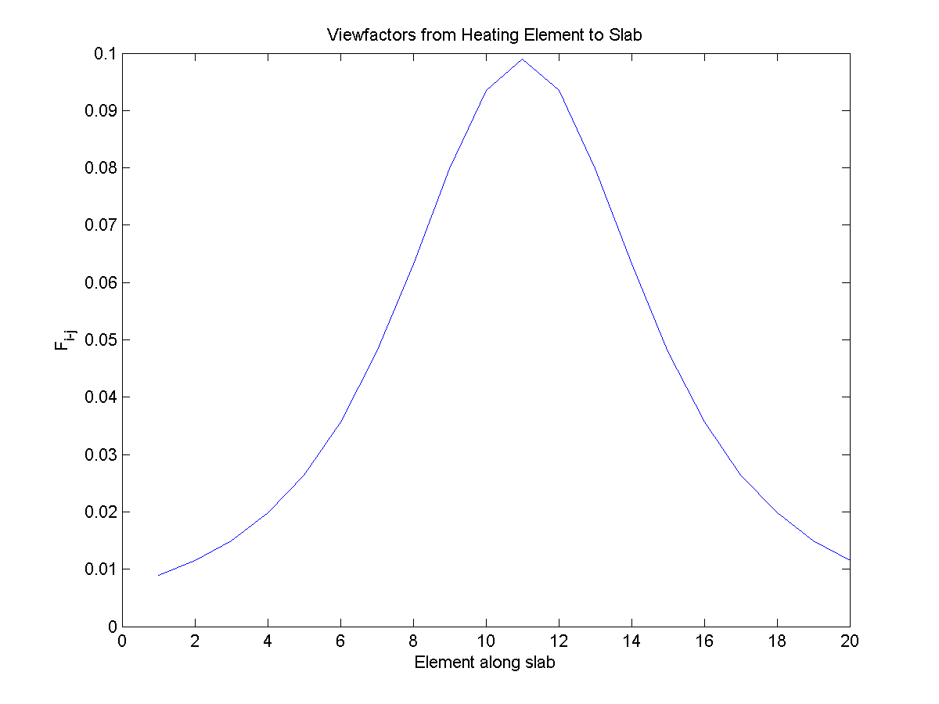

%Problem 2, Homework 5, ME 710

Lx = [ 0:10:190 0:10:190 zeros(1,5) 200\*ones(1,5) ] ;

Rx = [10:10:200 10:10:200 zeros(1,5) 200\*ones(1,5)];

Ty = [zeros(1,20) 50\*ones(1,20) 10:10:50 10:10:50 ];

Ly = [zeros(1,20) 50\*ones(1,20) 0:10:40 0:10:40 ];

F = zeros(length(Lx));

for i = 1:length(Lx)

for j = 1:length(Lx)

if i ~= j

d1 = sqrt((Rx(j)-Lx(i))^2+(Ly(i)-Ty(j))^2);

d2 = sqrt((Lx(j)-Rx(i))^2+(Ly(j)-Ty(i))^2);

s1 = sqrt((Rx(j)-Rx(i))^2+(Ty(j)-Ty(i))^2);

s2 = sqrt((Lx(j)-Lx(i))^2+(Ly(j)-Ly(i))^2);

F(i,j) = abs(d1+d2-s1-s2)/20;

end

end

end

sum(F)

%Heating element is located at 11

%Slab is located at 21:40

plot(F(11,21:40));